Lab 13 – Creating and Using Views Joellyn Johnson, jajohnson23

1.CREATE VIEW EMPLOYEES_VIEW AS

SELECT employee_id, last_name AS employee, department_id

FROM employees;

2. SELECT * FROM EMPLOYEES_VIEW;

The output should be: 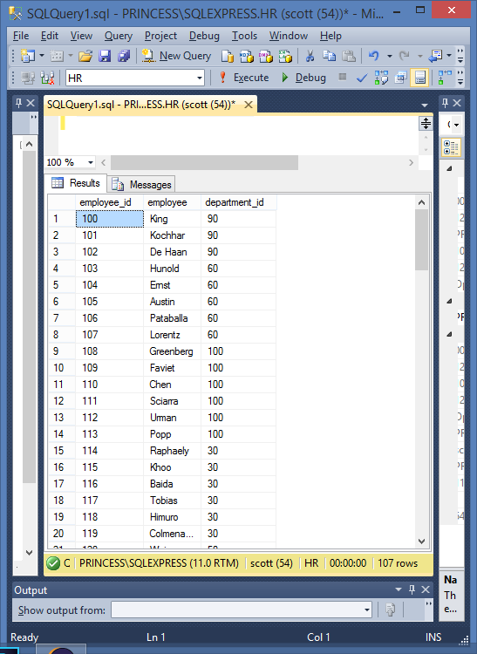

3. SELECT employee, department_id

FROM EMPLOYEES_VIEW;

The output should be:

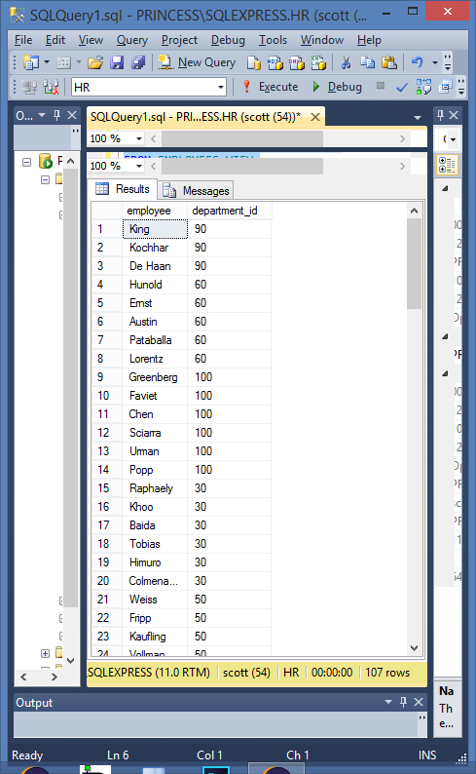

4. CREATE VIEW DEPT_50

AS

SELECT employee_id AS empno,

last_name AS employee,

department_id AS deptno

FROM employees

WHERE department_id = 50;

5. UPDATE DEPT_50

SET deptno = 80

WHERE employee = 'Matos';

6. Done – got a screen that shows employees with a window to check columns desired, employee_id, last_name and department_id checked. This generated code was also in view SELECT employee_id, last_name AS employee, department_id

FROM dbo.employees

Mine worked without the dbo. prefix though